Database Relationship Diagram:
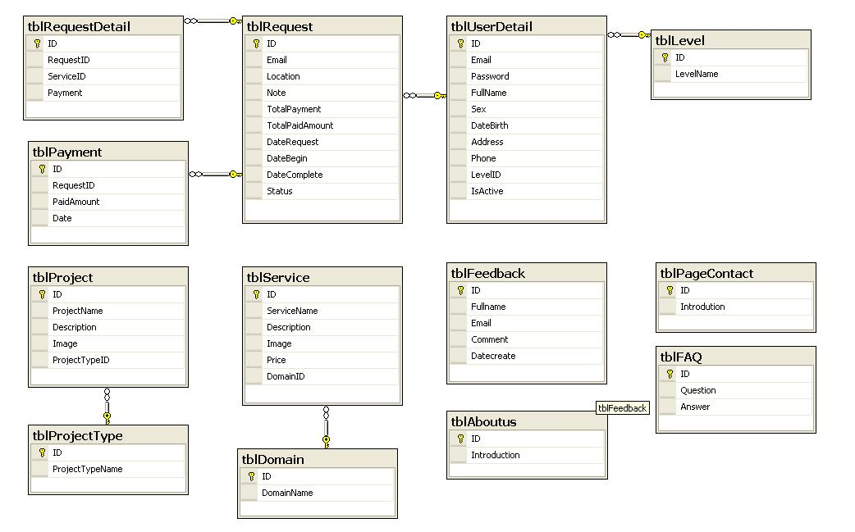
Table Definition:
Table FAQ: store information of FAQ page.
tblFAQ
Field name | Data type | Null | Default value | Table-ref field | Key | Description
Id | Int | NO |  |  | PK | Identity(1, 1)
Question | Nvarchar(500) | NO
Answer | Nvarchar(1000) | NO

Table PageContact: store information of contact page.
tblPageContact
Field name | Data type | Null | Default value | Table-ref field | Key | Description
Id | Int | NO |  |  | PK | Identity(1, 1)
Introdution | Nvarchar(4000) | NO |  |  |  | Contact information

tblFeedback
Field name | Data type | Null | Default value | Table-ref field | Key | Description
Id | Int | NO |  |  | PK | Identity(1, 1)
Fullname | Nvarchar(100) | NO |  |  |  | User’s name
Email | Nvarchar(70) | Yes |  |  |  | User’s email
Comment | Nvarchar(2000) | NO |  |  |  | Feedback content
Datecreate | Nvarchar(10) | NO |  |  |  | Date that feedback was created
Table Feedback: store user’s feedback information.

tblAboutus
Field name | Data type | Null | Default value | Table-ref field | Key | Description
Id | Int | NO |  |  | PK | Identity(1, 1)
Introdution | Nvarchar(4000) | NO |  |  |  | About us information
Table AboutUs: sotore information of About us page.

Table ProjectType: store information about project types.
tblProjectType
Field name | Data type | Null | Default value | Table-ref field | Key | Description
Id | Int | NO |  | tblProject | PK | Identity(1, 1)
ProjectTypeName | Nvarchar(100) | NO |  |  |  | Name of the project type

Table Project: store information about projects.
tblProject
Field name | Data type | Null | Default value | Table-ref field | Key | Description
Id | Int | NO |  |  | PK | Identity(1, 1)
ProjectName | Nvarchar(100) | NO |  |  |  | Name of project
Description | Nvarchar(100) | Yes |  |  |  | explanation of project
Image | Nvarchar(100) | Yes |  |  |  | Image for the project
ProjectTypeID | Int | NO |  | tblProjectType | FK | Name of the project type
Table Level: store the level(role) of the users.
tblLevel
Field name | Data type | Null | Default value | Table-ref field | Key | Description
Id | Int | NO |  | tblUserDetail | PK | Identity(1, 1)
LevelName | Nvarchar(100) | NO |  |  |  | Name of level(role)

tblUserDetail
Field name | Data type | Null | Default value | Table-ref field | Key | Description
Id | Int | NO |  |  | PK | Identity(1, 1)
Email | Nvarchar(100) | NO |  | tblRequest |  | User’ email(username)
Password | Nvarchar(100) | NO |  |  |  | User’s password
FullName | Nvarchar(100) | NO |  |  |  | Name of user
Sex | Bit | Yes | Yes |  |  | User’s sex
DateBirth | Nvarchar(100) | Yes |  |  |  | User’s birthdate
Address | Nvarchar(100) | NO |  |  |  | User’s address
Phone | Nvarchar(100) | Yes |  |  |  | User’s phone number
LevelID | Int | NO | 2 | tblLevel | FK | The level(role) of the user
IsActive | Bit | NO | Yes |  |  | Name of the project type
Table UserDetail: store information about users.

tblDomain
Field name | Data type | Null | Default value | Table-ref field | Key | Description
Id | Int | NO |  | tblService | PK | Identity(1, 1)
DomainName | Nvarchar(100) | NO |  |  |  | Name of domain
Table Domain: store information about Domain.
Table Service: store information about services.
tblService
Field name | Data type | Null | Default value | Table-ref field | Key | Description
Id | Int | NO |  |  | PK | Identity(1, 1)
ServiceName | Nvarchar(100) | NO |  |  |  | Name of service
Description | Nvarchar(2000) | Yes |  |  |  | explanation for service
Image | Nvarchar(100) | Yes |  |  |  | Image for the service
Price | decimal(18, 2) | Yes |  |  |  | Price for the service
DomainID | Int | NO |  | tblDomain | FK | Domain that the service belong to

Table Request: store information about request of users.
tblRequest
Field name | Data type | Null | Default value | Table-ref field | Key | Description
Id | Int | NO |  | tblRequestDetail, tblPayment | PK | Identity(1, 1)
Email | Nvarchar(70) | NO |  | tblUserDetail | FK | User’s email(username)
Location | Nvarchar(100) | Yes |  |  |  | explanation for service
Note | Nvarchar(300) | Yes |  |  |  | Note for request
TotalPayment | decimal(18, 2) | Yes | 0 |  |  | Total payment of the request
TotalPaidAmount | decimal(18, 2) | Yes | 0 |  |  | Total paid amount( amount was paid by client for the request)
DateRequest | Nvarchar(10) | NO |  |  |  | Date that the request was created
DateBegin | Nvarchar(10) | Yes |  |  |  | Date that the request will begin
DateComplete | Nvarchar(10) | Yes |  |  |  | Date that the request will complete
Status | Nvarchar(30) | NO |  |  |  | Domain that the service belong to

tblRequestDetail
Field name | Data type | Null | Default value | Table-ref field | Key | Description
Id | Int | NO |  |  | PK | Identity(1, 1)
RequestID | Int | NO |  | tblRequest | FK | The request that detail belong to
ServiceID | Int | NO |  |  |  | The service(detail) that client requested
Payment | decimal(18, 2) | Yes |  |  |  | Payment for each detail(service)
Table RequestDtail: store information about detail of request.

Table payment: store information about payment of request.
tblPayment
Field name | Data type | Null | Default value | Table-ref field | Key | Description
Id | Int | NO |  |  | PK | Identity(1, 1)
RequestID | Int | NO |  | tblRequest | FK | The request that payment belong to
PaidAmount | decimal(18, 2) | Yes |  |  |  | Amount was paid by client
Date | Nvarchar(10) | Yes |  |  |  | Date that amount was paid

